Survey of Cover Crop Management in Nebraska
Maxwel C Oliveira¹, Liberty Butts² and Rodrigo Werle¹
¹University of Wisconsin-Madison and ²University of Nebraska-Lincoln
Corresponding author: Dr. Rodrigo Werle, Assistant Professor, Department of Agronomy, 1575 Linden Drive, Madison, WI 53706 United States of America
Abstract: The need for more sustainable agriculture increase growers interest on cover crops in the past decade. In 2017, a survey was conducted with Nebraska growers in an effort to evaluate current cover crop management strategies in soybean, field corn, and seed corn. Eighty-two Nebraska stakeholders answer the survey, being 80% identified themselves as growers. The survey showed that 87% respondents managed cover crops, and the averaged cover crop planted on the farm basis is 32%. The primary method of establishing cover crop following soybeans and field corn was by drilling. In seed corn, interseeding was the main seeding strategy for cover crop. Cereal rye appeared as the most adopted cover crop species (either alone or in mixtures with radishes or legumes). Over 95% of respondents utilize herbicides for cover crop termination in the spring before crop planting. Glyphosate is used by 100% of survey respondents for cover crop termination. According to 93% of respondents, cover crop improved weed control by supressing winter-annual and late-summer annual weed species. The major impacts of incorporating cover crops into a production system are reduced soil erosion and weed suppression. The biggest challenge reported by cover crop adopters is planting and establishing a decent stand before winter. According to the results of this survey, there are different management strategies, positive outcomes, and challenges that accompany cover crop adoption in Nebraska. These results will help producers, agronomists, and researchers better guide cover crop adoption, management, and research need in Nebraska and surrounding states.

1. Introduction
Nebraska is historically a top field crops producer in the United States. In the last century, the diversity of crops in Nebraska was highest in the 1950/60s with corn, sorghum, alfalfa, wheat, hay, and soybean but it has decreased throughout decades [1]. Corn has always been a dominant crop in the state followed by soybean, which increasily replaced sorghum and oats after 1960s [1]. The summed planted area of corn and soybean in Nebraska was 6,1 million ha in 2018 [2], which represents 30% of the state territory.
With corn and soybean widely planted in Nebraska, crop rotation is a commonly practice among growers, especially in eastern Nebraska. The dependence on corn and soybean rotation, in part, reduced crop diversity and imposed a strong selection pressure on Nebraska agroecosystems. As a result, pests outbreaks, chemical runoff or leaching (e.g. fertilizer and pesticide), and soil erosion are some of the issues of Nebraska agriculture. Integrated crop, nutrient and pest management strategies have been recommended to increase sustainability in agroecossystems [3] [4]. Amongst the sustainable strategies, conservation practices, including tillage and cover crops, gained importance in the last decades [5] [6].
The widely adoption of glyhosate resistant crops (e.g., corn and soybean) strongly contributed for the shift of conventionl tillage to no-till in cropping-systems [7]. No-till was easier to implement with the application of glyphosate. It was estimated that over 50% of growers in the US Midwest adopted tillage as a standard practice [8]. The benefit of using conservation practices led growers to increase interest in cover crops [9]. However, in Nebraska and upper US Midwest growers are facing challenges to implement cover crops in their systems. The use of cover crops is constrained by economic, biological, and farm operational factors [10] [11]. Some of the limitations include short growing season window, cover crop selection, planting, and termination.
A well establish cover crops could provide several benefits to agroecosystems, including weed suppression, pest management, reduced soil erosion, and increased soil health [12] [13]. For example, it is estimated that the use of cover crops in the Midwest have a potential to reduce 20% of NO3 in the Mississippi River [14]. In a survey, cover crops was listed as the fifth on future weed research and extension priority in Nebraska [15]. Therefore, there is a need to document Nebraska growers experiences and perceptions on adopting cover crop. A survey questionnaire might be a useful method for obtaining Nebraska stakeholders knowledge of perceptions about the use of cover crops. Also, a survey can demonstrate opportunities and challenges on managing cover crops to guide future research, extension, education, and improve grower decision making.
Surveys have become a standard practice to evaluate and document trends in agriculture. For example, several surveys have documented the impact of tillage [8], glyphosate [16], dicamba [17], pesticide application [18], and weed management [19], [15] in the US Midwest. Also, surveys have documented the use of cover crops in the United States [20], [21]. For example, [20] showed that crop diversity in a farm operation was the most important factor for cover crops adoption. Therefore, a cover crop survey focused on agronomic practices was developed with Nebraska stakeholders (growers, agronomists, industry representatives, and crop consultants). The objective of the survey was to evaluate cover crop management strategies adopted by Nebraska soybean, field corn and seed corn stakeholders.

2. Material and Methods
A paper copy survey was handle out during the 2017 Cover Crop Conference at the Eastern Nebraska Research and Extension Center, Ithaca, NE on February 14, 2017. The survey comprised eight sections (Figure 1). Questions focused on the demographics information (Q1-4, Figure 1A); questions on cover crop management during corn (Q5-7, Figure 1B), seed corn (Q8-10, Figure 1C), and soybean growing season (Q11-13, Figure 1D); questions on cover crop management into a corn (Q14-15, Figure 1E), seed corn (Q16-17, Figure 1F), and soybean (Q18-19, Figure 18-19) growing season; and general questions about cover crop management in Nebraska (Q20-24).
For most questions, results are presented in two fashions: (1) percent of respondents answering, and (2) percent number of hectares represented. Survey data were sorted, filter and analyzed usin the sort, filter, and count functions in Microsoft Excel.
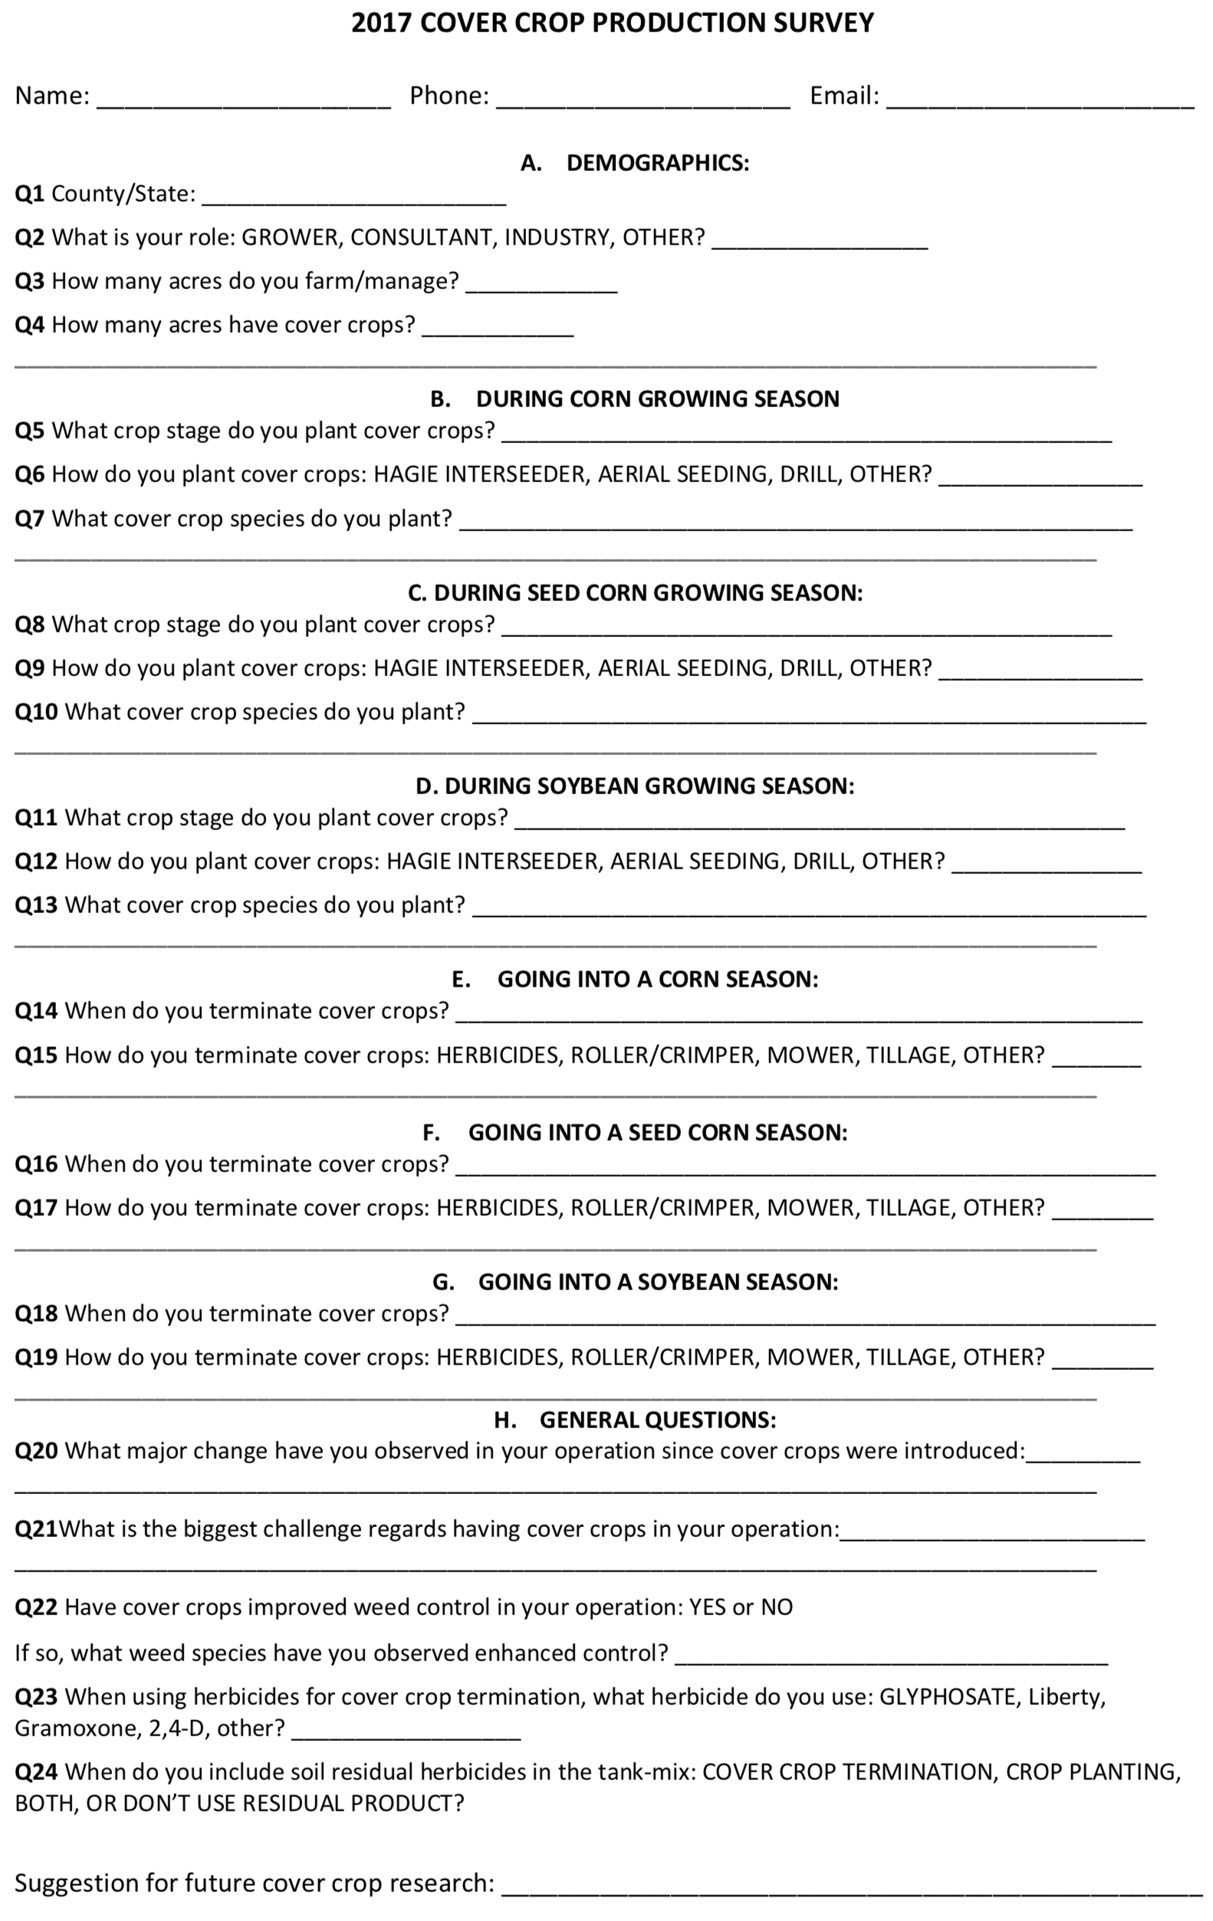
Survey questionnaire .

3. Results and Discussion

3.1 Demographics
A total of 82 individuals representing the soybean production area in Nebraska participated in the survey. Sixty-six participants identified themselves as growers (80%) and seven as consultants, industry representative or agronomists (9%). The majority (87%) of respondents integrate cover crops in their cropping-systems (n=XX). The total area managed by respondents was 149370 ha, with 24240 ha planted with cover crops, being 16% of total managed area.
The majority of survey respondents manage cover crops in eastern Nebraska, with 18990 ha of cover crops managed by growers. Nearly 50% of cover crops ha managed by survey respondents indentified as growers are located in Butler county, Nebraska (Figure 2). On the farm basis, respondents that reported planting cover crops varied from 2.5 to 100%, with an average of 32%.
From 2001 to 2005, it was documented only 11% of corn belt growers use cover crop ([21]). Recently, a large survey with growers across the United States showed that 88% of respondents planted cover crops in 2016 (SARE, 2017). The survey also showed that the area planted with cover crops increased nearly 60% from 2014 to 2016. Therefore, there is a growing trend in the use of cover crops in the United States. Most important is that growers are perceiving the benefits of planting cover crops. Further research is necessary to understand the reason of cover crops increase in Nebraska, Midwest, and the United States.
The steady increase on growers interest on cover crops is likely a combination of several factors, including reduced of crop productivity, popular pressure for sustaible production, cost reduction, and policy incentives (e.g. cost sharing and conservation programs). In a survey, over 50% of growers would plant cover crops if cost-sharing was available in the early 2000s [20]. With growers adoption, a new challenge is to increase the percentage of cover crops ha on the farm basis.
Map of Nebraska counties with the sum of total ha of cover crop managed by survey participants identified as growers.

3.2 Cover crop during the growing season
According to survey participants, cover crop establishement in Nebraska varied with cropping-system. In soybean years, 27% of survey respondents seed their cover crop prior to harvest while 73% after crop harvest (n=56, Table 1A). Drilling after crop harvest is the main method of cover crop in soybean years (72%, Table 1B), followed by aerial seeding (28%, n=53). None of respondents interseed cover crop in soybean. Cereal rye (Secale cereale) is used by 43% of the respondents while a cover crop mix (at least two species) is used by 57% (ceral rye plus oats [Avena sativa], radishes [Raphanus spp.], and/or hairy vetch [Vicia villosa] were common answers, n=57, Table 1C).
In field corn, 27% of respondents seed cover crop prior to harvest while 73% seed after crop harvest (n=59, Table 1A). Drilling after crop harvest is the main strategy for planting cover crops (66%) followed by aerial seeding (26%, tipically done when crop reaches maturity), and interseeding (8%, n=61, Table 1B). Cereal rye is used by 47% of the respondents, while a mix of species was used by 53% (cereal rye plus radishes, and/or vetch were the common answers, n=62, Table 1C).
In field corn and soybean drilling after crop harvest is a common management strategy for survey participants. Drilling has long been a management strategy in the Midwest. Fifteen years ago, a survey in Illinois, Indiana, Iowa, and Minnesota showed that nearly 70% of cover crop growers establish cover crop using drill after crop harvest [21]. Some researchers are demonstrating the importance of interseeding cover crops in corn and soybeans prior to crop harvest [22] [23]. A benefit of interseeding is cover crop establishment, especially legume species, which requires early planting for overwinter, and to produce satisfactory amount of biomass.
A shift in management during growing season occurred when survey respondents used cover crops in seed corn. Eighty-five percent of survey respondents seed cover crops prior to seed corn harvest while 15% plant after harvest (n=13, Table 1A). Interseeding cover crops is the main seeding practice in seed corn years (77%), followed by aerial seeding (15%) and drilling (8%, n=13, Table 1B). The in season cover crop planting fter male rows destruction benefit the establishemnt of cover crops, especially legumes. A mix of species is used by 100% of the respondnets in this system (radishes, turnips [Brassica rapa] and cereal rye mix was a common answer, n=13, Table 1C).
A standard practice is that survey respondents are likely to plant cereal rye alone or in mixtures with brassicas and legumes as cover crops. The use of cover crops mixtures might increase agroecosystem diversity, but did not provided benefits beyond cover crop monocultures [24]. [24] demonstrated that rye and rye mixtures (brassicas and legumes) produced the highest biomass, and cereal rye in mixtures accounted for nearly 80% of spring biomass. In general, cereals (e.g., oats and rye) and legumes (e.g., hairy vetch and crimson clover) are a good combination for producing large amounts of biomass cover and N-fixing, respectively. The seed mixture proportion would depend on the ultimate goal when managing cover crop. For example, with cereal rye/hairy vetch mixtures, [25] recommended higher proportion of the cereal for weed management but higher legume for N accumulation in the soil.

3.3 Cover Crop Termination and Herbicide Program
Survey respondents were asked when they terminate cover crops. One-hundred percent terminate cover crop two weeks prior seed corn planting (n= , Table 1D). Similar trending was observed with respondents that manage field corn (73%), and soybean (46%). Terminating cover crops at least two weeks prior to planting is one of the best cover crops practices recommended [26]. For exemple, Cornelius and Bradley (2017) showed that herbicide applications on early April rather than early May provided the best control of winter wheat (Triticum aestivum), cereal rye, annual ryegrass (Lolium multiflorum), crimson clover (Trifolium incarnatum), hairy vetch, and Austrian winter pea (Pisum sativum). In contrary, early terminated cover crop might not yield significant amount of biomass in the spring. High cover crop biomass is needed for weed suppression and for proving N to the agroecosystem in the spring [27]. It was reported that waiting extra two weeks (late April) for spring termination of hairy vetch produce significant increase of N for the subsequent corn [28]. Therefore, there will be trade-off when deciding the timing for cover crops termination, which depends on grower’s primary goal utilizing cover crops.
Termination is an important component for integrating cover crops in cropping-systems. Despite non-chemical strategies for terminating cover crops, including tillage and roller crimper [29] [30] [31] [32], more than 95% of survey respondents used herbicides (Table 1E). Therefore, it is likely the majority of survey respondents manage conventional cropping-systems. When herbicides are used, 100% of survey respondents spray glyphosate alone or in mixtures (Figure 3A). Glyphosate tank mixes with 2,4-D, paraquat (e.g., Gramoxone), glufosinate (e.g., Liberty), and others (e.g., saflufenacil [Sharpen], carfentrazone [Aim]) are used by 50%, 9%, 6%, and 3% of the survey respondents, respectively.
Our survey showed a strong confidence of Nebraska growers on herbicides, especially glyphosate. The effectiveness of herbicides on terminationg cover crops can present challenges for growers, and it is dependent on species, size, and application timing. The use of glyphosate alone would not be effective on cover crop control, especially when cover crops mixtures are present. It was documented that glyphosate alone provided nearly complete cereal rye control, but poor legume control (57%) [33]. The enhanced control of cover crop mixtures occur when glyphosate is tank mixed with other herbicides. For example, glyphosate tank mixed (2,4-D or dicamba) provided nearly 30% higher hairy vetch control than glyphosate alone [34]. These results highlighted that when Nebraska growers use herbicide for terminating cover crops, glyphosate tank mixes with other herbicide site-of-action (SOA) are the best option, especially when legumes are present.
The use of pre-emergent (PRE) herbicides is a commonly strategy for weed management in Nebraska. Forty-four percent of survey respondents apply PRE herbicides at cover crop termination and crop planting, 33% at cover crop termination, 21% at crop planting, and only 2% do not use PRE herbicides (Figure 3B). The PRE herbicides can provide long soil residual activity, which might control early and late germinating weed species. In Nebraska, waterhemp (Amaranthus tuberculatus) is ranked the most troublesome weed species [15], mostly because easily capacity to evolve resistance to herbicides and its extend germination period. According to [15], the most common PRE herbicide treatment used by Nebraska growers at planting is atrazine + mesotrione + S-metolachor and cloransulan-methyl + sulfentrazone for corn and soybean, respectively. These herbicide combinations are in accordance to recommendations of crop consultants and advisors for providing multiple herbicide SOA [35].
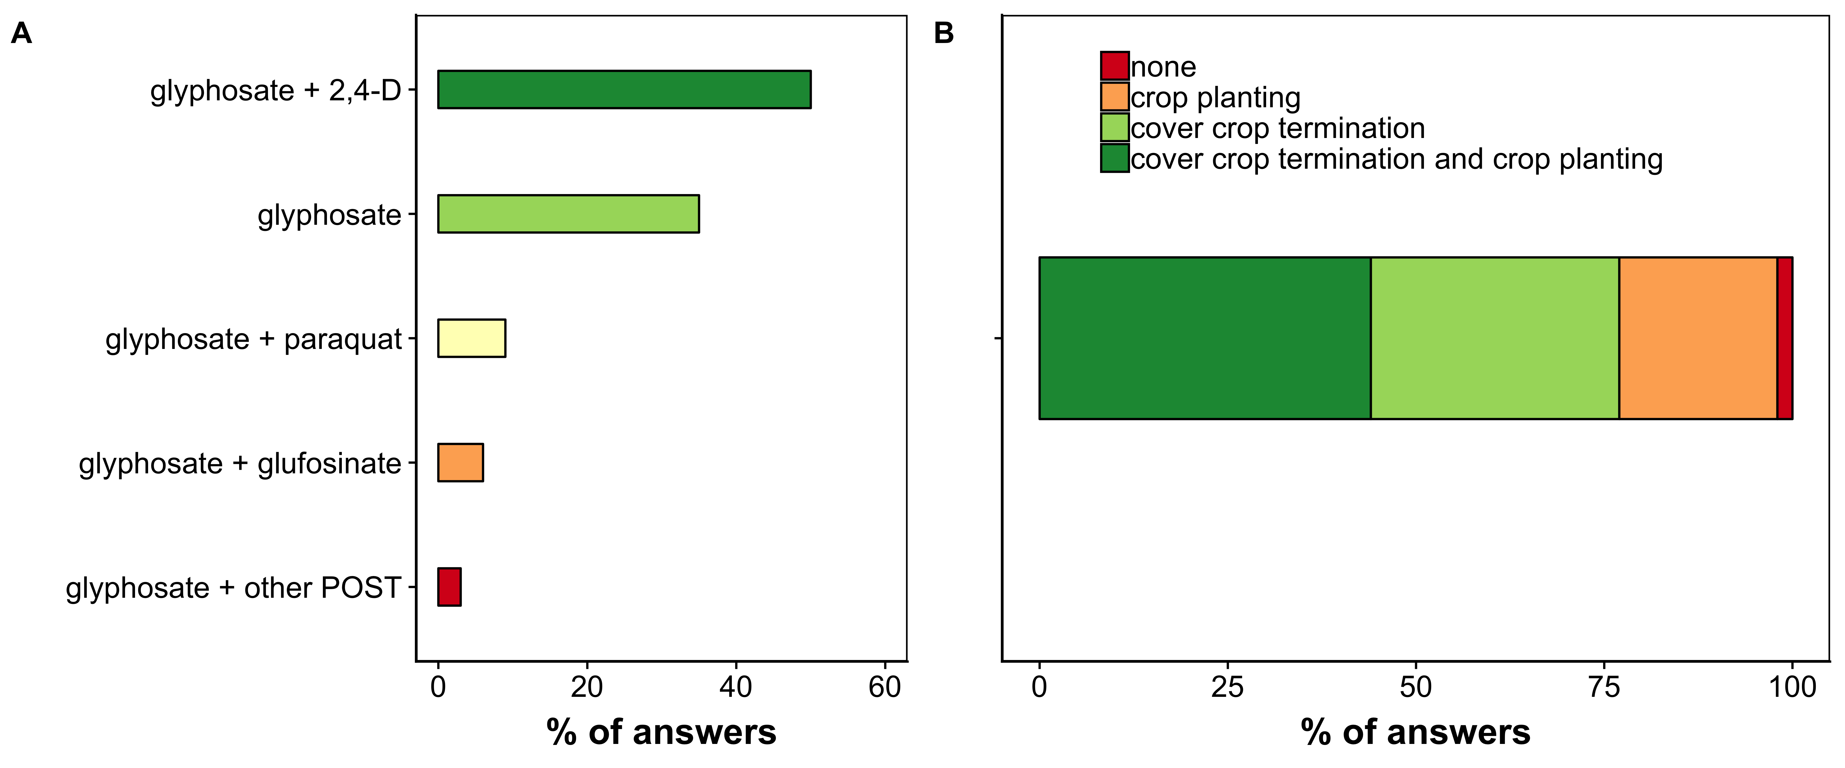
Herbicide programs used for cover crop termination (A) and timing for preemergence herbicide application (B) according to survey participants of Nebraska.

3.3 Impact of Cover Crop in Production Systems
Cover crops incorporation to cropping-systems has the potential to provide direct and indirect services (e.g., increase soil organic matter, and reduce soil erosion). However, measuring the cover crop services to agroecosystems is difficult [13]. In Nebraska, the majority of survey respondents think that the major impact of cover crops is soil erosion reduction (45%, n=42, Figure 4). In fact, cover crop aboveground biomass function as a physical barrier against rainfall and wind, slowing down soil erosion [12] [36]. The bare ground area reduction from agricultural production is likely the main visible benefit provided by cover crops.
The increased soil organic matter (24%), increased soil tilth (19%), and increased soil water inflitration (10%) were also services that cover crops provided to survey respondents of Nebraska. These services increase soil health but their benefits would occur in the long-term use of cover crops [13]. Although legume cover crops can provided significant amounts of N-enriched biomass [37], only five percent of survey respondents belive that cover crops improved soil fertility in their operation. The N accumulation is strongly correlated to the amount of legume biomass [12], which depends on stand, winter overkill, and termination timing.
Weed suppression is a secondary benefit of cover crops according to survey respondents in Nebraska (29%, Figure 4). In a meta-analysis, [38] reported that cover crops could provided early season weed control comparable to chemical and mechanical weed control strategies. For example, cereal rye used as cover crop reduced density and biomass of henbit and horseweed (Conyza canadensis) by over 90% in Nebraska [39]. Also, cereal rye provided near 85% suppression of Palmer amaranth (Amaranthus palmeri) in cottom [40]. Horseweed and Palmer amaranth are two of the most difficult to control weed species, mostly because of herbicide resistance evolution. Therefore, well established cover crops have a potential to supress problematic and hard to control weed species in Nebraska and other geographies.
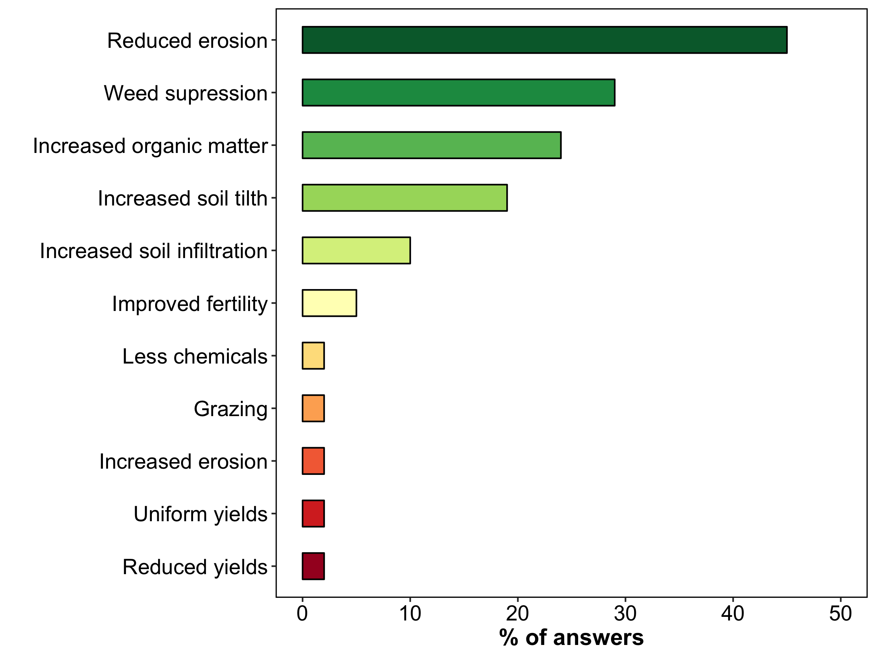
Major change in agroecosystems according to survey participants of Nebraska.
Addicional described benefits were reduced pesticide use, increased grazing ability, and uniform yields (2%). A few respondents reported reduced crop yields and increased erosion where cover crops have been adopted (2%; Figure 4). Ninety-three percent of survey respondents answer that cover crop improve weed control in their operation (n=54, Figure 4A). Also, according to survey participants, the most effective weeds that cover crop enchenced control were winter annual (79%), followed by late-season summer annual (55%), and early-season summer annual (26%, n=38, Figure 4B). Therefore, cover crops might potentially supress henbit (Lamium amplexicaule), downy brome (Bromus tectorum), horseweed, waterhemp, and giant ragweed (Ambrosia trifida), which are commonly winter annual and summer annual species found in nebraska [41] [42].
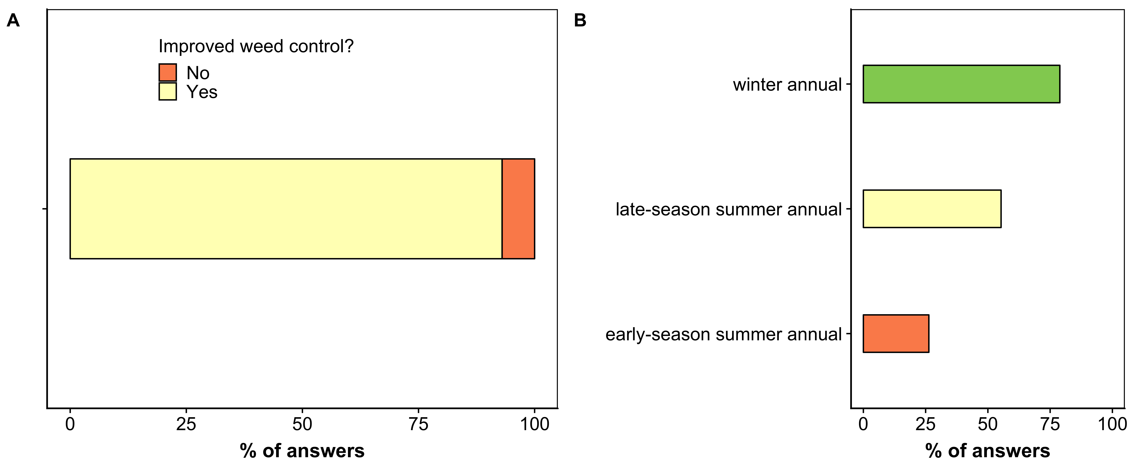
Cover crops improved weed control (A) and the biology of weed species supressed by cover crops (B) according to survey participants of Nebraska.

3.4 Challenges With Incorporationg Cover Crops
According to survey respondents adopting cover crops, the biggest challenge has been planting and establishing stand before winter due to short growing season, time and/or equipment (56%, Figure 5). Planting cover crops often required the same basic equipment used in no-till cropping-systems [13]. However, in the upper Midwest, the lack of growing season left after harvest, lack of rain, and winter kill are the main constraints for cover crop establishment in the fall. The limitation of implementing cover crops during the growing season is the absence of adequate planting method that provide cover crop stand without damaging cash crops.
Termination of cover crops in the spring was ranked as the second biggest challenge (37%, Figure 5). A poorly controlled cover crop could become a weed, reducing crop establishment and cash crop yields potential. In addition, late terminated cover crops have a potential to host seedlings pathogens [43]. The incidence of seedling desease (e.g., Pythium spp.) and low corn emergence occur when cover crop (winter rye) was terminate whithin 10 days prior to corn planting [44].
The use of herbicides for weed control in Nebraska is impeding cover crop establishment in the fall according to 7% of survey respondents (Figure 4B). These herbicides are likely from the residual activity of postemergence (POST) application in corn and soybeans. For enhancing waterhemp and Palmer amaranth control, growers are advised to apply soil residual tank mixed with other POST herbicides. Depending on weather, some herbicides could last long enough to cause crop crop failure. For example, [45] demonstrated that herbicide products commonly used in corn and soybeans, such as pyroxasulfone, imazethapyr, fomesafen, and flumetsulan, have a high potential to cause negative impact on cover crop establishment in the fall.
The costs of incorporating cover crops was a challenging for 5% of survey respondents. The cost is mostly linked to cover crop seeds. According to SARE 2017, nearly 50% of cover crop growers paid from $25 to 50 ha⁻¹ for cover crop seeds, especially legumes. However, growers have the option of use cover crops as forages or to reduce the amount of nutrient and herbicides in their operation. It is documented that growers that that receive cost sharing and used cover crops for grazing livestock or forage tipically derive positive net returns to cover crops [46]. Other benefts such as increased soil helth and reducing farming inputs is hard to measure and it is likely to be view as an investiment in the long-term [13]. The profitability of cover crops weights according to the ultimate goal of cover crop growers.
Two percent of survey respondents reported crop yield reduction when adopting cover crops (Figure 6). A meta-analysis over 65 years of research showed that if properly managed, winter cover crops do not reduce yields in corn [27]. For example, the incorporation of cereal rye following corn rotation with soybean resulted in comparable yields where no cover crop was grown [47]. Therefore, it is likely that cover crop would not reduce yields if used according to the best management practices.
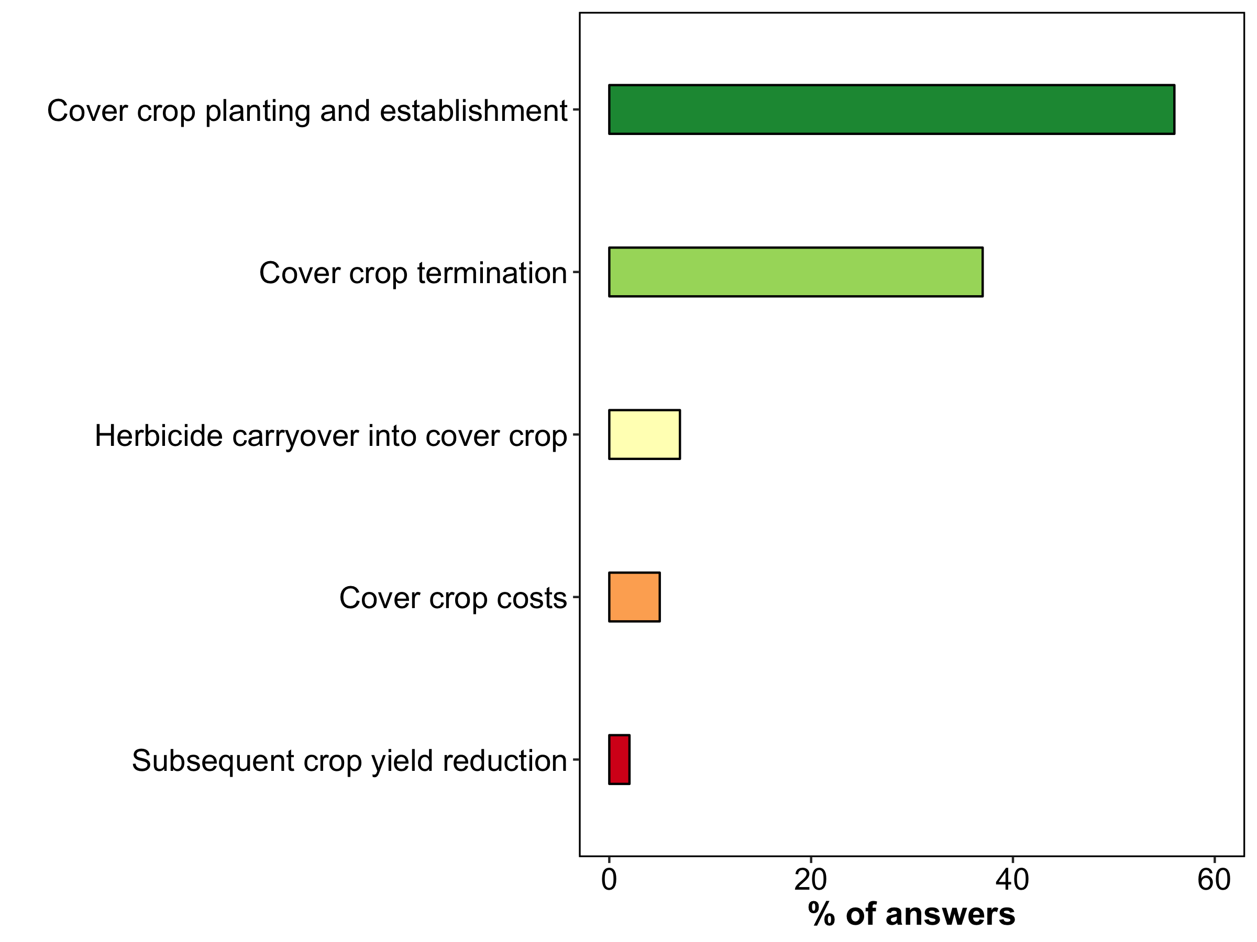
Challenges for adopting cover crops according to survey participants of Nebraska

5. Conclusions
The adoption of cover crops is increasing across Nebraska and the United Sates. There are many ways cover crop can be incorporated in cropping-systems and the results of this survey highlight the main strategies, benefits, and challenges observed by cover crop adopters in Nebraska.
When deciding how best to use cover crops, it is important to consider the ultimate goal. The goal could be the increase soil organic matter, increased nutrient availability to subsequent crops, reduce soil compaction, supply forage for livestock, and/or supress weeds. Answering these questions will help identify the cover crops strategies that offer the best chance of success for meeting the goal.

4. Acknowledgements
Thanks to the growers and consultants for participating, UNL Extension Educator Keith Glewen for allowing us to conduct this survey, and UNL WCREC Office Associate Jacqueline Herrick for processing the data.

5. References
1. Hiller, T.L.; Powell, L.A.; McCoy, T.D.; Lusk, J.J. Long-Term Agricultural Land-Use Trends In Nebraska, 1866–2007. Great Plains Research 2009, 19, 225–237.
2. USDA, N. QuickStats Ad-hoc Query Tool Available online: https://quickstats.nass.usda.gov/ (accessed on Feb 20, 2019).
3. Wu, W.; Ma, B. Integrated nutrient management (INM) for sustaining crop productivity and reducing environmental impact: A review. Science of The Total Environment 2015, 512, 415–427.
4. McDaniel, M.D.; Tiemann, L.K.; Grandy, A.S. Does agricultural crop diversity enhance soil microbial biomass and organic matter dynamics? A meta-analysis. Ecological Applications 2014, 24, 560–570.
5. Knowler, D.; Bradshaw, B. Farmers’ adoption of conservation agriculture: A review and synthesis of recent research. Food Policy 2007, 32, 25–48.
6. Baumgart-Getz, A.; Prokopy, L.S.; Floress, K. Why farmers adopt best management practice in the United States: A meta-analysis of the adoption literature. Journal of Environmental Management 2012, 96, 17–25.
7. Duke, S.O.; Powles, S.B. Glyphosate: A once-in-a-century herbicide. Pest Management Science 2008, 64, 319–325.
8. Givens, W.A.; Shaw, D.R.; Kruger, G.R.; Johnson, W.G.; Weiler, S.C.; Young, B.G.; Wilson, R.G.; Owen, M.D.K.; Jordan, D. Survey of Tillage Trends Following the Adoption of Glyphosate-Resistant Crops. Weed Technology 2009, 23, 150–155.
9. Bergtold, J.S.; Duffy, P.A.; Hite, D.; Raper, R.L. Demographic and Management Factors Affecting the Adoption and Perceived Yield Benefit of Winter Cover Crops in the Southeast. Journal of Agricultural and Applied Economics 2012, 44, 99–116.
10. Sarrantonio, M.; Gallandt, E. The Role of Cover Crops in North American Cropping Systems. Journal of Crop Production 2003, 8, 53–74.
11. Dunn, M.; Ulrich-Schad, J.D.; Prokopy, L.S.; Myers, R.L.; Watts, C.R.; Scanlon, K. Perceptions and use of cover crops among early adopters: Findings from a national survey. Journal of Soil and Water Conservation 2016, 71, 29–40.
12. Blanco-Canqui, H.; Shaver, T.; Lindquist, J.; Shapiro, C.; Elmore, R.; Francis, C.; Hergert, G. Cover Crops and Ecosystem Services: Insights from Studies in Temperate Soils. Agronomy Journal 2015, 107, 2449–2474.
13. Bergtold, J.S.; Ramsey, S.; Maddy, L.; Williams, J.R. A review of economic considerations for cover crops as a conservation practice. Renewable Agriculture and Food Systems 2017, 34, 62–76.
14. Kladivko, E.J.; Kaspar, T.C.; Jaynes, D.B.; Malone, R.W.; Singer, J.; Morin, X.K.; Searchinger, T. Cover crops in the upper midwestern United States: Potential adoption and reduction of nitrate leaching in the Mississippi River Basin. Journal of Soil and Water Conservation 2014, 69, 279–291.
15. Sarangi, D.; Jhala, A.J. A Statewide Survey of Stakeholders to Assess the Problem Weeds and Weed Management Practices in Nebraska. Weed Technology 2018, 32, 642–655.
16. Culpepper, A.S. Glyphosate-Induced Weed Shifts. Weed Technology 2006, 20, 277–281.
17. Werle, R.; Oliveira, M.C.; Jhala, A.J.; Proctor, C.A.; Rees, J.; Klein, R. Survey of Nebraska Farmers’ Adoption of Dicamba-Resistant Soybean Technology and Dicamba Off-Target Movement. Weed Technology 2018, 32, 754–761.
18. Bish, M.D.; Bradley, K.W. Survey of Missouri Pesticide Applicator Practices, Knowledge, and Perceptions. Weed Technology 2017, 31, 165–177.
19. Werle, R.; Miller, J. Survey of Nebraska Soybean Producers: Current and Future Statuses of Weed Management. Journal of Extension 2018, 56, 9.
20. Singer, J.W.; Nusser, S.M.; Alf, C.J. Are cover crops being used in the US corn belt? Journal of Soil and Water Conservation 2007, 62, 353–358.
21. Singer, J.W. Corn Belt Assessment of Cover Crop Management and Preferences. Agronomy Journal 2008, 100, 1670–1672.
22. Noland, R.L.; Wells, M.S.; Sheaffer, C.C.; Baker, J.M.; Martinson, K.L.; Coulter, J.A. Establishment and Function of Cover Crops Interseeded into Corn. Crop Science 2018, 58, 863–873.
23. Youngerman, C.Z.; DiTommaso, A.; Curran, W.S.; Mirsky, S.B.; Ryan, M.R. Corn Density Effect on Interseeded Cover Crops, Weeds, and Grain Yield. Agronomy Journal 2018, 110, 2478–2487.
24. Appelgate, S.R.; Lenssen, A.W.; Wiedenhoeft, M.H.; Kaspar, T.C. Cover Crop Options and Mixes for Upper Midwest Corn–Soybean Systems. Agronomy Journal 2017, 109, 968–984.
25. Hayden, Z.D.; Ngouajio, M.; Brainard, D.C. Rye–Vetch Mixture Proportion Tradeoffs: Cover Crop Productivity, Nitrogen Accumulation, and Weed Suppression. Agronomy Journal 2014, 106, 904–914.
26. Nascente, A.S.; Crusciol, C.A.C.; Cobucci, T.; Velini, E.D. Cover Crop Termination Timing on Rice Crop Production in a No-Till System. Crop Science 2013, 53, 2659–2669.
27. Marcillo, G.S.; Miguez, F.E. Corn yield response to winter cover crops: An updated meta-analysis. Journal of Soil and Water Conservation 2017, 72, 226–239.
28. Sainju, U.M.; Singh, B.P. Tillage, Cover Crop, and Kill-Planting Date Effects on Corn Yield and Soil Nitrogen. Agronomy Journal 2001, 93, 878–886.
29. Mirsky, S.B.; Curran, W.S.; Mortensen, D.A.; Ryan, M.R.; Shumway, D.L. Control of Cereal Rye with a Roller/Crimper as Influenced by Cover Crop Phenology. Agronomy Journal 2009, 101, 1589–1596.
30. Wortman, S.E.; Francis, C.A.; Bernards, M.L.; Drijber, R.A.; Lindquist, J.L. Optimizing Cover Crop Benefits with Diverse Mixtures and an Alternative Termination Method. Agronomy Journal 2012, 104, 1425–1435.
31. Bavougian, C.M.; Sarno, E.; Knezevic, S.; Shapiro, C.A. Cover crop species and termination method effects on organic maize and soybean. Biological Agriculture & Horticulture 2018, 35, 1–20.
32. Frasconi, C.; Martelloni, L.; Antichi, D.; Raffaelli, M.; Fontanelli, M.; Peruzzi, A.; Benincasa, P.; Tosti, G. Combining roller crimpers and flaming for the termination of cover crops in herbicide-free no-till cropping systems. PLOS ONE 2019, 14, e0211573.
33. Palhano, M.G.; Norsworthy, J.K.; Barber, T. Evaluation of Chemical Termination Options for Cover Crops. wete 2018, 32, 227–235.
34. Cornelius, C.D.; Bradley, K.W. Herbicide Programs for the Termination of Various Cover Crop Species. wete 2017, 31, 514–522.
35. Norsworthy, J.K.; Ward, S.M.; Shaw, D.R.; Llewellyn, R.S.; Nichols, R.L.; Webster, T.M.; Bradley, K.W.; Frisvold, G.; Powles, S.B.; Burgos, N.R. et al. Reducing the Risks of Herbicide Resistance: Best Management Practices and Recommendations. Weed Science 2012, 60, 31–62.
36. Lu, Y.-C.; Watkins, K.B.; Teasdale, J.R.; Abdul-Baki, A.A. Cover Crops in Sustainable Food Production. Food Reviews International 2000, 16, 121–157.
37. Blanco-Canqui, H.; Claassen, M.; Presley, D. Summer Cover Crops Fix Nitrogen, Increase Crop Yield, and Improve Soil–Crop Relationships. Agronomy Journal 2012, 104, 137.
38. Osipitan, O.A.; Dille, J.A.; Assefa, Y.; Knezevic, S.Z. Cover Crop for Early Season Weed Suppression in Crops: Systematic Review and Meta-Analysis. Agronomy Journal 2018, 110, 2211–2221.
39. Werle, R.; Burr, C.; Blanco-Canqui, H. Cereal Rye Cover Crop Suppresses Winter Annual Weeds. Canadian Journal of Plant Science 2017, 498–500.
40. Palhano, M.G.; Norsworthy, J.K.; Barber, T. Cover Crops Suppression of Palmer Amaranth (Amaranthus palmeri) in Cotton. Weed Technology 2018, 32, 60–65.
41. Werle, R.; Sandell, L.D.; Buhler, D.D.; Hartzler, R.G.; Lindquist, J.L. Predicting Emergence of 23 Summer Annual Weed Species. Weed Science 2014, 62, 267–279.
42. Werle, R.; Bernards, M.L.; Arkebauer, T.J.; Lindquist, J.L. Environmental Triggers of Winter Annual Weed Emergence in the Midwestern United States. Weed Science 2014, 62, 83–96.
43. Bakker, M.G.; Acharya, J.; Moorman, T.B.; Robertson, A.E.; Kaspar, T.C. The Potential for Cereal Rye Cover Crops to Host Corn Seedling Pathogens. Phytopathology 2016, 106, 591–601.
44. Acharya, J.; Bakker, M.G.; Moorman, T.B.; Kaspar, T.C.; Lenssen, A.W.; Robertson, A.E. Time Interval Between Cover Crop Termination and Planting Influences Corn Seedling Disease, Plant Growth, and Yield. Plant Disease 2017, 101, 591–600.
45. Cornelius, C.D.; Bradley, K.W. Carryover of Common Corn and Soybean Herbicides to Various Cover Crop Species. Weed Technology 2017, 1–11.
46. Plastina, A.; Liu, F.; Miguez, F.; Carlson, S. Perceived benefits and net returns. Renewable Agriculture and Food Systems 2018, 11.
47. De Bruin, J.L.; Porter, P.M.; Jordan, N.R. Use of a Rye Cover Crop following Corn in Rotation with Soybean in the Upper Midwest. Agronomy Journal 2005, 97, 587–598.

